Welcome to the Thriplow Society | Short history of Thriplow | programme
A SHORT HISTORY OF THRIPLOW
Thriplow is a small village in south Cambridgeshire, the underlying soil is chalk and springs abound making it fertile and easily cultivated. It is surrounded by low hills which gives it an unique micro-climate, dry and comparatively warm. Thriplow gets its name from ‘Trippa’s Law’; Trippa being the eponymous Bronze Age chieftain reputedly buried in the tumulus just SE of the church. ‘Law’ comes from OE hlaw or hill, thus Trippa’s Hill. The Tumulus must have been a prominent landmark, 80 feet wide and 15-20 feet high, capped with white chalk and lying on the Icknield Way; it would have been visible from all directions for many miles.
The first written mention of Thriplow is in two books, Liber Eliensis & Liber Ramsienses, ‘The Book of Ely’ & ‘The Book of Ramsey Abbey’. These two books tell the story of how Byrhtnoth, Ealdorman of Essex and brother-in-law to the King, was killed fighting the Danes at the Battle of Malden in Essex in the year 991. He had been hospitably entertained prior to the battle by the Abbot and monks of Ely, and in return he bequeathed Thriplow among his other estates to the Abbey. In the Domesday survey of 1086, the village was held by the abbot of Ely, Geoffrey de Mandeville’s tenant Sigar the Staller, with a few acres usurped by Harduin de Scalers. So there were two manors, the Bury, the main manor belonging to the Abbot later the Bishop of Ely, and Barentons Manor held by Sigar.
The population has fluctuated over the centuries, dropping in the 14th century due to over-population, famine and dearth, culminating in the Black Death, 1349, and rising to its highest in the 19th century. It is now approximately the same as it was in 1279!
Date | Source | Population
1086 | Domesday | 181 *
1279 | Hundred Rolls | 440 *
1327 | Lay Subsidy | 150 tax payers*
1523 | Lay Subsidy | 260 *
1546 | Subsidy Rolls | 150 *
1640 | “ | 60*
1674 | Hearth Tax | 220
1676 | Compton Census | 165
1685 | “ | 213
1794 | Vancouver | 320
1801 | Census | 334
1851 | “ | 521
1921 | “ | 381
1999 | “ | 440 + 220 (Heathfield)

* = a multiplier of 5 has been used to include women and children.
Heathfield is a satellite estate originally part of Duxford Airfield.
The village is essentially arable and covers approx. 2,500 acres. In Iron Age and Roman times there were several small family settlements scattered over the landscape, usually not far from a source of water. When the Saxons arrived they either took over existing settlements by force or settled in between these holdings. Christianity first came to England in the seventh century and by the tenth century the lord of these lands, Byrhtnoth, had built a small Minster church near the great tumulus that stood out against the skyline on the Icknield Way.
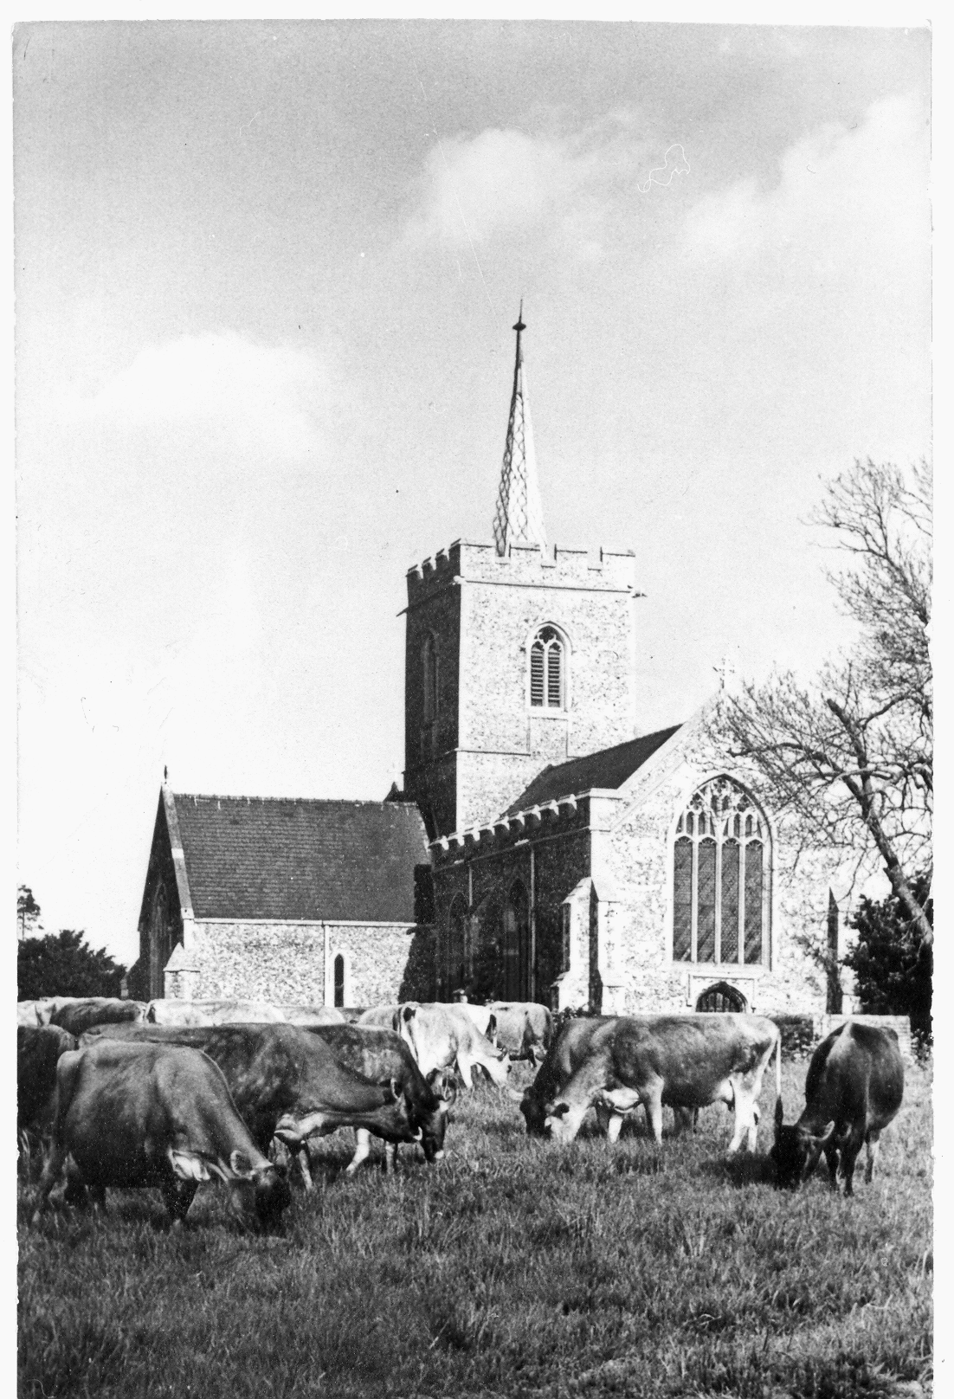
Agriculture and Religion, the two defining movements in the making of the landscape of South Cambridgeshire.
From the beginning of the eleventh century, the great monastic house of Ely had acquired most of Thriplow and may have set about consolidating the numerous holdings into some semblance of a planned village surrounded by three great open fields cultivated by the strip system, though this may have happened in the tenth century. The various branches of the Icknield Way were crossed at right-angles by paths leading to the Manors resulting in a grid system of roads and paths. By the fourteenth century subinfeudation or the splitting up of the main manor had resulted in five manors in Thriplow - the Bury, Barentons, Bacons, Crouchmans and Pittensaries, as well as the Rectory which was owned by Peterhouse.
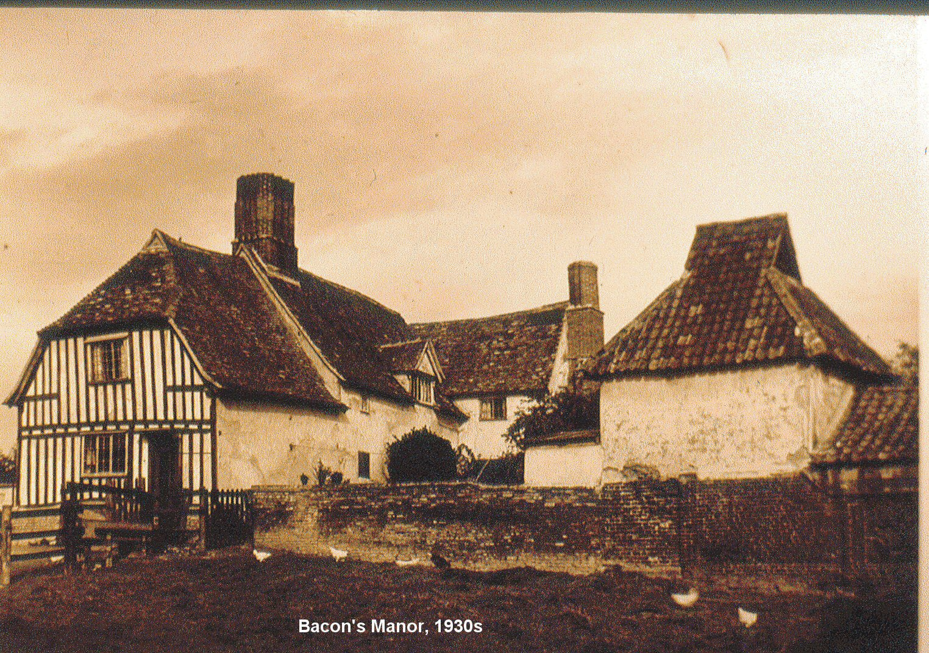
Bacon's Manor in the1930s
By the middle of the nineteenth century most of these manors were once again in the hands of one man, Joseph Ellis, who in 1840 was the prime mover in enclosing the fields. His son, also Joseph, acquired the remaining manors and by 1918, his son, Arthur Cole Ellis, owned or leased 1,728 acres. Most of Thriplow was then in the hands of one man as it had been in 991, but the wheel had not yet turned full circle, for in 1928, Arthur Cole Ellis sold up and the land was once again split between a few large landowners, and many small owner/occupiers, as it had been at the dawn of the second millennium, before the Saxon Lord Byrhtnoth died, leaving his estates to the monks of Ely

