A Virtual Walk into History

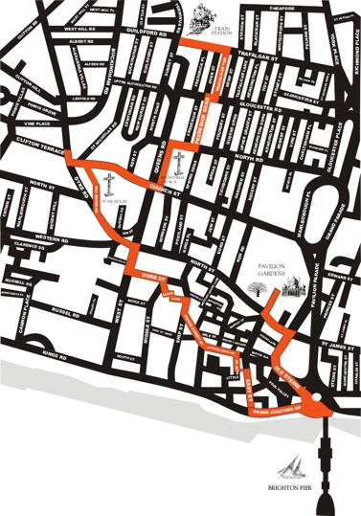
Historian Geoff Mead has created this guided tour from the train station to the sea.

The gentle 2-hour walk criss-crosses through conventional tourist areas. It highlights 17 places of historical interest representing the varied faces of Brighton.

You can find out more about each place on the route at www.mybrightonandhove.org.uk

1. The Station

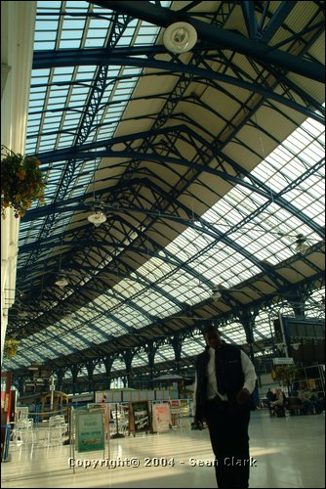
The tour starts at the station. There’s a wow factor the moment visitors step out of the train. Look up and you’ll see a wonderful piece of Victorian engineering: a huge glass roof, beautifully clean, with thousands of sheets of glass.

The railway arrived in the 1840s. Everyone thought rich passengers would revive the town’s fortunes. In fact, the tickets were so cheap that the town was inundated with London day-trippers. They brought their food with them and left the beach full of litter. Brighton shopkeepers were seething.

No one could decide where to put the station. In many resorts, the tracks run down to the sea. However, Brighton’s hills are steep and the valley was full of expensive housing. Sixteen sites were proposed. The railway company finally put the station on a plateau cut into the cliff-face, on the outskirts of the 1840s town.

Go out of the station and immediately turn left under a bridge beneath the station entrance. Walk under the bridge, and take the second right into a narrow alleyway called Trafalgar Terrace.

2. Trafalgar Terrace

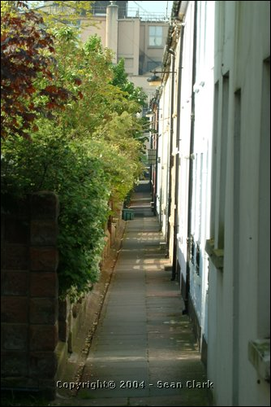
Two minutes walk from the station, and suddenly you’re in suburbia. This is a twitten, a Sussex word for alleyway. It's almost like a rural lane, with trees hanging over the front gardens.

This is a fossilised landscape. Brighton’s mediaeval fields determined the shape of these streets. The fields were collections of tiny parallel strips of land, like pencils in a box. When the Old Town expanded, builders bought up the strips of land.

The result is a public walkway between the front doors and front gardens of Trafalgar Terrace. The houses were built on one narrow strip of land. Another strip was probably acquired for the front gardens. The ancient field division has become a pathway.

Walk to the end of the alleyway. Turn right into Gloucester Road and immediately left into Frederick Gardens.

3. Frederick Gardens

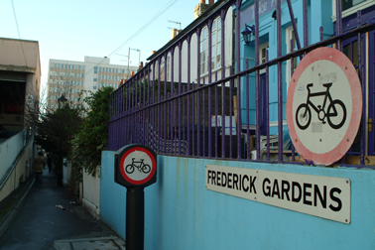
Industry and agriculture existed side by side in this tiny alley. Nowadays, a terrace of pretty cottages face onto the back wall of a postal sorting office.

The cottages were built on a market garden. That’s why the alley is called Frederick Gardens. These gardens supplied Regency Brighton with food. They were rural islands in a growing industrial zone.

The Regent Iron and Brass foundry, the town’s major employer, occupied the site of the postal sorting office. The foundry was moved here in 1823 as demand grew for its Regency ironwork. There was no Health and Safety in those days - the area would have been noisy, hot and polluted.

Walk to the end of Frederick Gardens, and out into busy North Road.

4. North Road

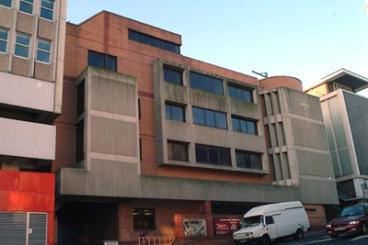
We come out into a very busy street. North Road was originally a mediaeval field boundary. It was the main shopping High Street when the North Laine was the industrial centre of Brighton. Trams ran up and down here until the 1930s.

After the Second World War, the whole area went into decline as manufacturing moved out to the Brighton estates.

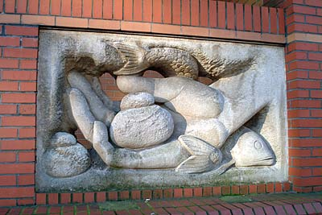
Cross the street towards a stark modern building, with a cross on the far right-hand facade. This is the Brighthelm church and community centre.

On the wall of the Centre, there is an attractive sculpture by Eric Gill, illustrating the loaves-and-fishes parable. It reflects Brighton’s role as a fishing and farming community.

Turn right at the sculpture, and on the left you’ll see a small turning with a ramp and some steps, which takes you into the churchyard of the Brighthelm Centre.

5. Brighthelm churchyard

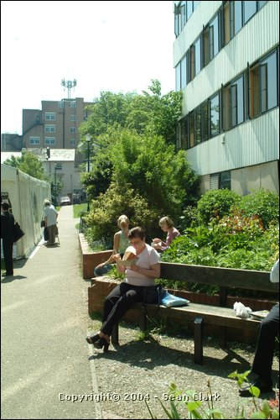
Walk through the attractive churchyard. This is a ‘zone in transition’. Round every city centre, there is an area of shifting, rootless population.

Migrants to a city don’t settle at the edges. They come into the city centre by train, looking for somewhere cheap to stay. That’s why the Community Base and the YMCA are situated near here. Early in the morning, you will see the street people.

At the far side of the churchyard, you’ll see a series of small shops, many selling second-hand goods. These are the remnants of a very poor quarter, which existed on this site in the early nineteenth century.

At Church Street turn right, cross Queens Road, and immediately go up a very steep hill, with a long flint wall running away on the left. This is a continuation of Church Street. Past the rear entrance of St Nicholas Church, cross Dyke Road diagonally into Clifton Terrace.
6. Clifton Terrace

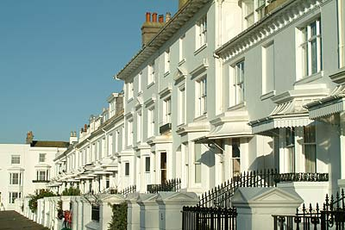
Clifton Terrace is one of the must-have places in Brighton. It was built in 1845, after the station was established. Everything west of the station went upmarket, as the middle-class moved towards the clean air of Hove.

Swanky merchants didn’t want fishermen’s housing, so the traditional flint and brick was covered in stucco. The stucco looks pale in old prints, so nowadays it’s painted creamy white. The original black iron railings were probably manufactured at the foundry next to Frederick Gardens.

Go and look at the private gardens on the other side of the street. You’ll find rosemary and lavender; plants that thrive on Brighton’s intense light.

Turn back into the church grounds and walk down the slope to St Nicholas church.

7. St Nicholas Church

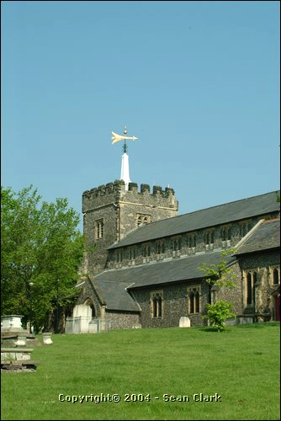
Brighton’s parish church is a curious relic. It is the oldest building in Brighton. The church survived a raid by French pirates, who burnt the mediaeval town of Brighthelmstone in 1533.

Why was it built on a hill? To avoid coastal erosion? To be protected from French pirates? Probably so that a fire lit on the big flat church tower could provide a beacon for fishermen.

There are spectacular views from the churchyard. You’re standing on the spine of a ridge. Lower down, the old town grew up on a defendable site by a stream.

Go downhill past the church and continue down the brick path to Wykeham Terrace.

8. Wykeham Terrace

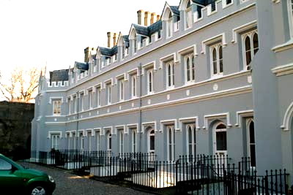
This is the site of a scandal. The southern part of Wykeham Terrace was built by a Protestant order of nuns as a home for ‘fallen’ women.

The home was a refuge for a village girl accused of stuffing her baby down a toilet. Constance Cox was acquitted, but worked as a cleaner at this home for the rest of her life. On her deathbed, she confessed she had murdered her child.

Cavalry officers were the sex symbols of their day. The northern part of Wykeham Terrace was built slightly later, and served for a while as the officer’s mess for the cavalry at Preston Parks. So the terrace housed a stimulating combination of officers, nuns and ex-prostitutes.

Continue downhill to the Clock Tower. Turn right down West Street towards the sea and take the first left into Duke Street.

9. Duke Street

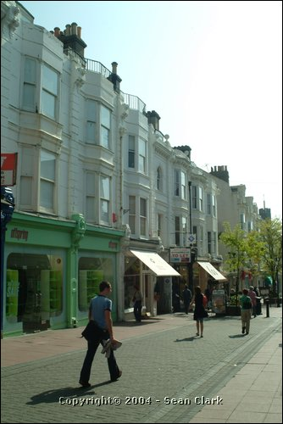
Duke Street is one entrance to the Lanes, the popular name for the Old Town of Brighton. The famous cricket family, the Wisdens, had a sports shop here for many years. It is now a street of high fashion shops and fancy bars.

Victorian horse-buses were diverted up this street, because North Street was too steep. This created traffic congestion, so the northern part of the street was demolished in a 1870s road-widening scheme.

That’s why there are two distinct sides to this street. On one side, there are older bow-fronted buildings, all of different heights. On the other, you can see a uniform terrace of much bigger white Victorian stucco buildings..

Walk down Duke Street and turn first right into Middle Street. Immediately turn left into Dukes Lane.

10. Dukes Lane
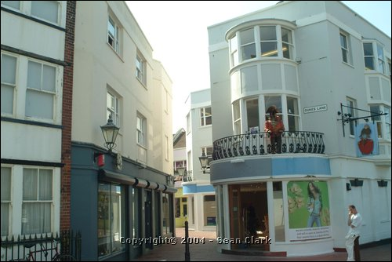
Brighton is not very old, compared with nearby Lewes or Chichester. The original medieval town was eroded by sea, burnt by French, and flattened by storms. However, Brighton’s Lanes district is one of very few surviving examples left in Britain of a Tudor fishing town.

The Lanes were due to be demolished in the early 1960s – they were seen as dirty and run-down. Thankfully, public opinion turned against the scheme.

Dukes Lane is a clever pastiche. Most visitors will think they are in the historic Lanes. But this Lane is no more than 20 years old. Previously, the site was derelict except for lock-up garages.

Go to the end of Dukes Lane and turn right into Ship Street. Follow this road until Prince Albert Street bears off left at the Friends Centre.

11. Friends Centre

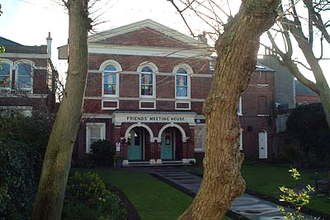
This lovely walled garden is a calming spot. It contains an early nineteenth century Quaker Meeting House.

The town centre is full of non-conformist places of worship. There’s a Swedenborgian mission and a gorgeous synagogue nearby. Yet the Church of England church is on the hill outside the town, out of sight, out of mind.

This has always been a radical city. Brighton voted for the first Labour MP in Sussex. It is Britain’s largest gay city outside Central London. There are two universities. Brighton goes its own way and bucks the system.

Walk along Prince Albert Street to the Town Hall. Past the town hall, turn right into Little East Street. Beyond a set of nineteenth century cottages with walls made from tarred beach pebbles, turn left down a winding unmarked alleyway marked ‘To East Street’.

12. Quadrophenia Alleyway

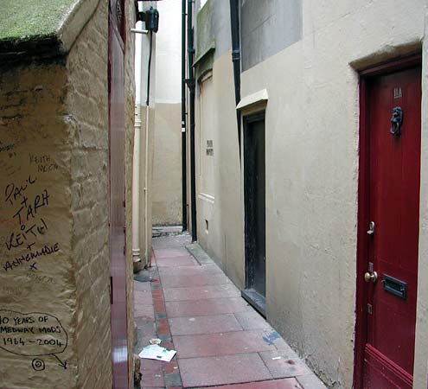
People come from all over the world to find this alleyway. The cult film Quadrophenia was set in Brighton in the 1960s, the period of the Mods and Rockers. One of the major scenes takes place in this alleyway. Two lovers escape the police and fall through a doorway into a yard.

The alley is a shrine to Mods. It’s very dingy, often smelly, and frequently covered in graffiti. The doorway is still there, hopefully better secured now!

No-one’s tidied up this corner of Brighton. It’s like a wild area on a nature reserve. It is neither part of tourist Brighton or window-shopping Brighton.

Go to the end of Quadrophenia Alley, and turn right into East Street.

13. East Street

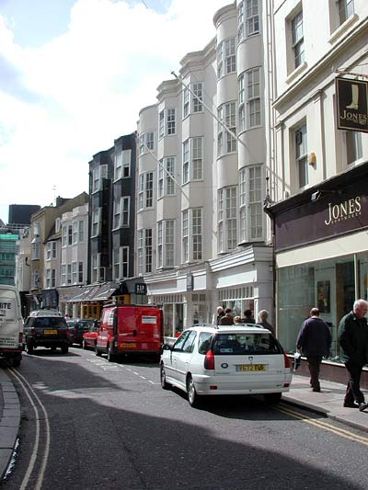
This is window-shopping Brighton: full of expensive shoe shops, fashion stores, swanky restaurants and nice bars.

It used to be the town slum. East Street was a very damp, low-lying area; the haunt of fishermen and farm labourers. This was the town’s East End.

The street became desirable when the Royal Pavilion was built. The palace was at one end of the street, and the sea was at the other. It's similar to the transformation of the London Docklands.

At the end of East Street, turn left along Grand Junction Road and cross to the seafront. Head left to Brighton Pier.

14. Brighton Pier
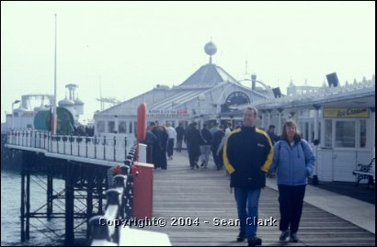
This is the fifth most visited tourist attraction in the UK. By day, it offers excellent views of the city. However, the best time to see the pier is when it is lit after nightfall by thousands of light bulbs.

The first pier was built as a ferry terminal. Brighton offered the quickest ferry route to Paris. The original Chain Pier was built in 1823 but destroyed in a storm in 1897.

Piers became places to take the sea air. Breathing ozone was healthy, but going out in small boats was uncomfortable. So fashionable visitors walked out on piers, dressed up in their finest clothes, to see and be seen. That’s why pier seating faces the walkways, rather than the waves.

Cross back to Grand Junction Road on the north side and turn right to follow the road round behind the Royal Albion Hotel (this is the site of the house of Dr Richard Russell who advocated sea bathing in the mid 1700s). Cross north into the Old Steine.

15. Old Steine

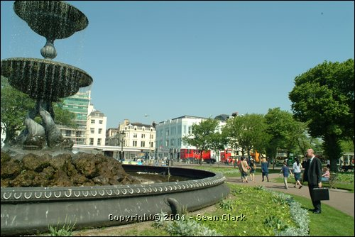
The Steine was an area of low ground next to the Old Town. A stream ran through it, which now flows beneath the lawns, through huge Victorian sewers

The fishermen used this grassy area as a workplace. It was a public area where they could mend boats, dry nets, cure fish, and keep animals.

The upper classes took over the Steine. The fishermen were gradually moved off the common as Brighton became fashionable. The Steine was laid out with flowerbeds and gravel walks, so the gentry could promenade.

Cross the busy road westwards into North Street and follow that west to the second turning on the right, Pavilion Buildings. Go through the Indian South Gate into the gardens of the Royal Pavilion.
16. Pavilion Gardens

The Royal Pavilion is a Western idea of an exotic place. It’s been compared to a Moorish palace, an Indian temple, and the Kremlin. For a royal palace, though, it’s pretty poky. If you look at the front of the building, you can see the original 3-bay Georgian farmhouse. It’s basically a two-storey house with twiddly bits.
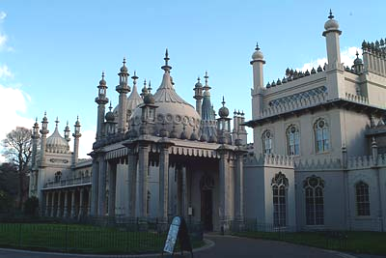
The gardens are based on original plans by John Nash. However, the prince ran out of money, so the plans were never implemented till a few years ago. Instead, Great East Street, the road to London, called, ran across right in front of the Pavilion.

There’s a lovely open-air café in the gardens. This was originally a seaside refreshment booth, moved here during the Second World War, when the seafront was out of bounds. The same family still runs the café. You can sit out under the trees, look at the Pavilion, and listen to someone playing an oboe or a saxophone.

A short walk from the cafe is the recently restored Brighton Museum and Art Gallery.

17. Brighton Museum
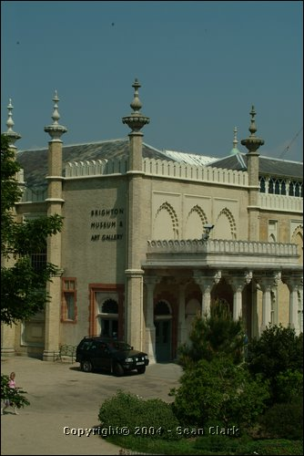
The museum re-opened in 2002 after a makeover. It is a real 21st century museum, with hi-tech audiovisual aids and interactive devices.

They had the brilliant idea of opening the back door. The old entrance used to be in Church Street, a busy road. Now you can walk out of the Pavilion, through the gardens, and straight into the museum.

It's a fabulous museum. As well as the local history galleries, you’ll see the cultural legacy of Brighton. There are objects from around the world, brought here by people who came back from the colonies between the Wars. The founder of the museum, Henry Willett, donated a world-class collection of pottery. The city is a melting pot, and the museum reflects its many faces.

End the walk in the cafe in the Museum or the Pavilion Gardens.

